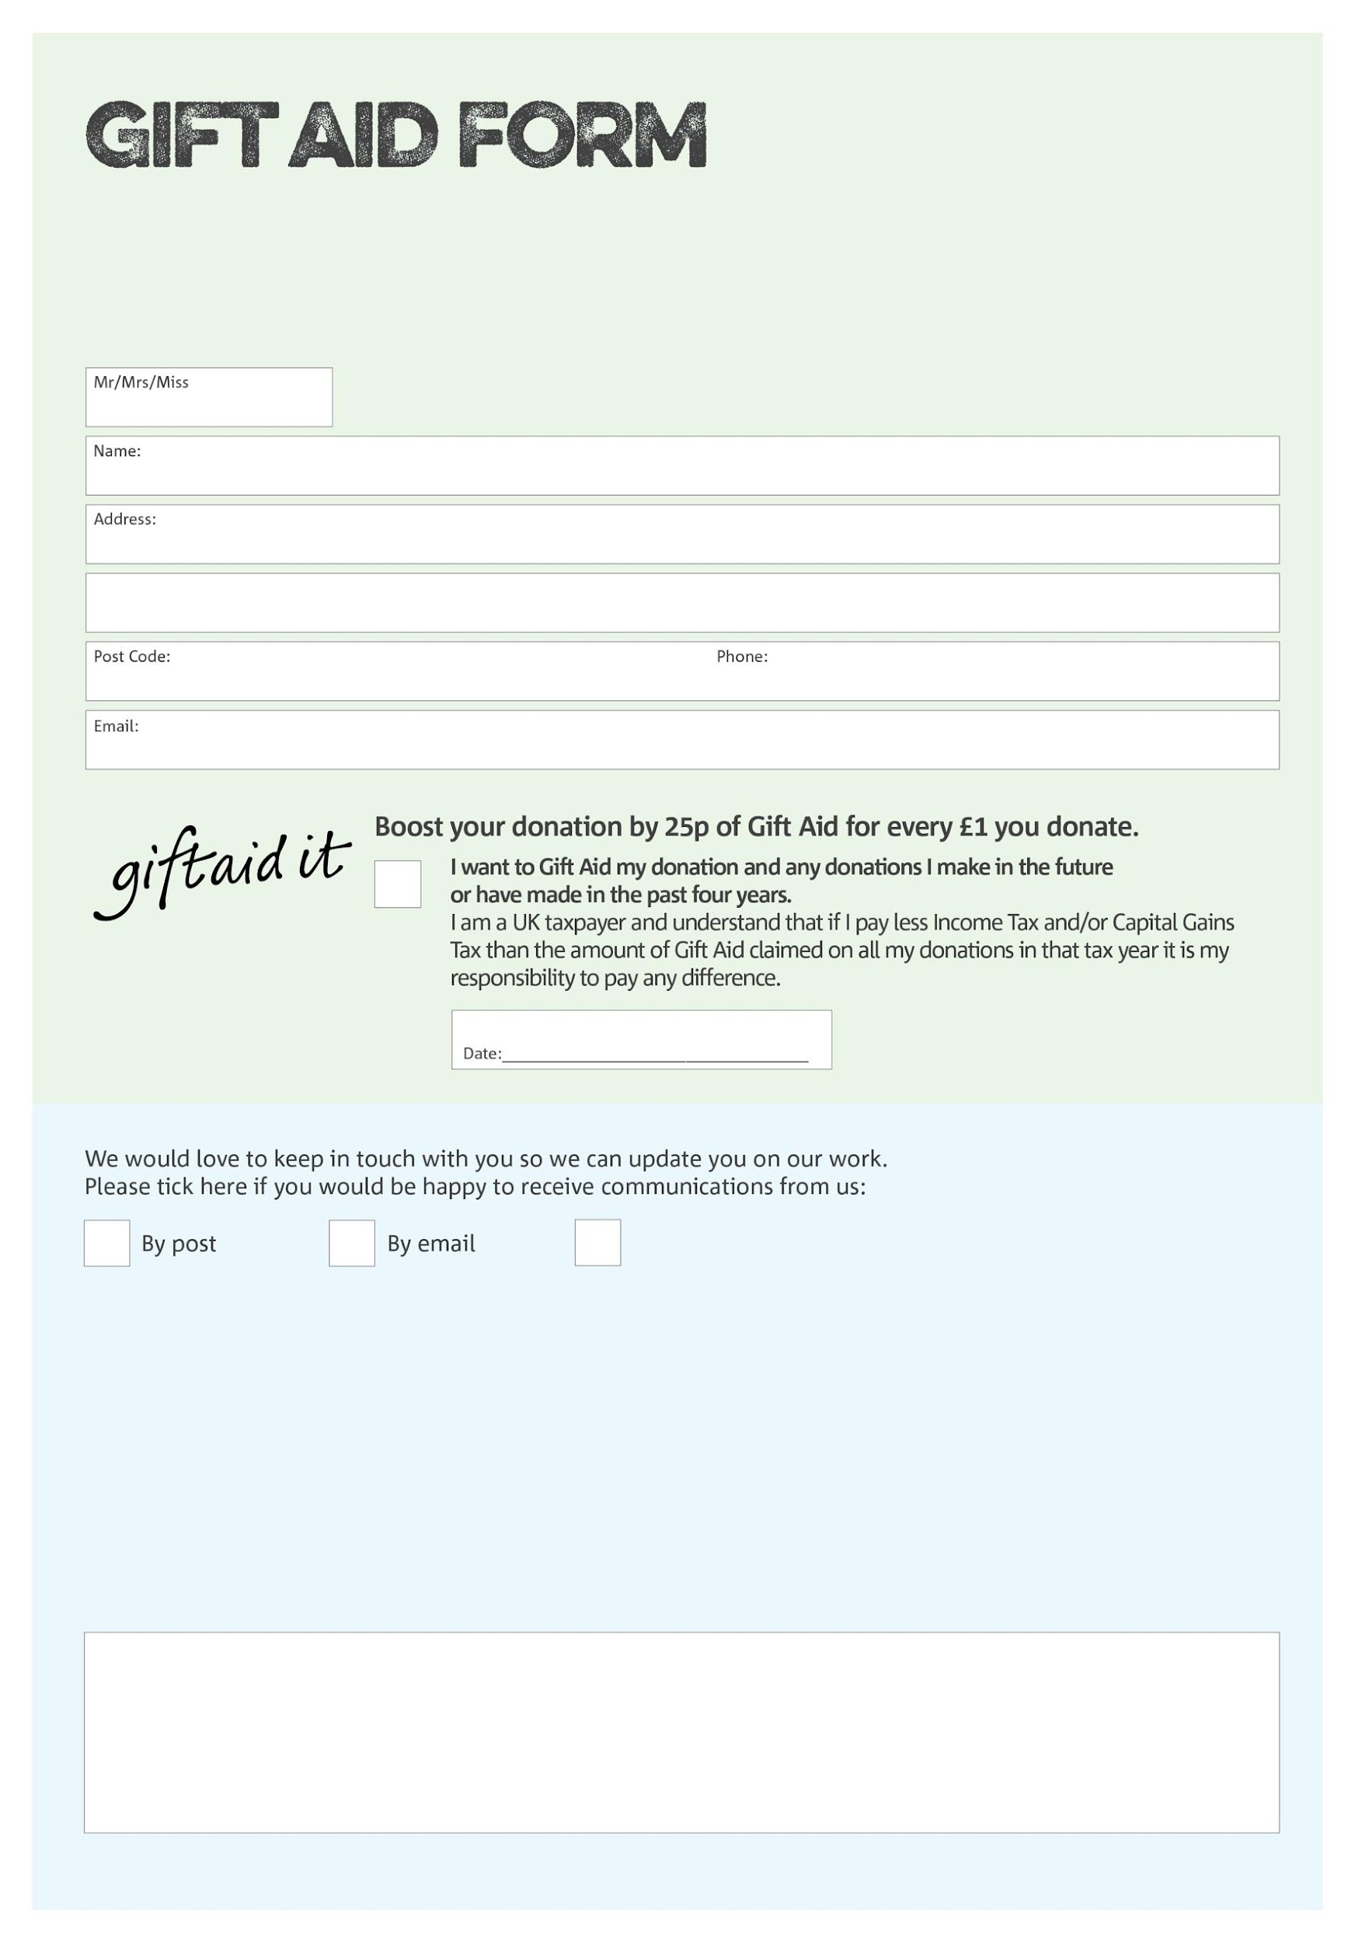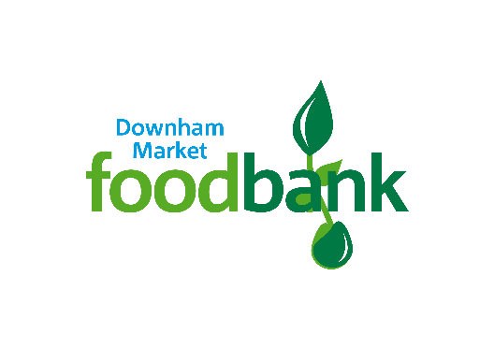

By filling in this form Downham Market Foodbank will receive an extra 25p for every £1 you give at no extra cost to you. Thank you!

**Data protection**

*Downham Market Foodbank is committed to protecting your privacy and will process your personal data in accordance with current Data Protection legislation. Downham Market Foodbank collects information to keep in touch with you and supply you with information relating to our work. To unsubscribe from our newsletter, send a message to the email address above with the word unsubscribe in the subject line. A full data privacy statement for financial donors is available from the foodbank on request.’*

Charity Number 1202187. Registered in 06/03/2023

We would love to know why you have chosen to donate to Downham Market Foodbank. If you would like to share your motivation let us know below:

You can change your preferences any time by contacting us on 01366 384474 or emailing us at info@downhammarket.foodbank.org.uk

I do not wish to receive future communications from Downham Market Foodbank